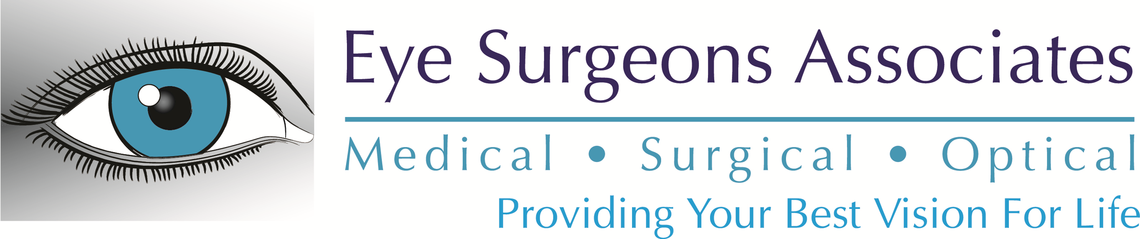

LASIK Drawing Official Rules
- No Purchase Necessary. The drawing is sponsored by Eye Surgeons Associates ("Sponsor"). Odds of winning depend upon the number of eligible and properly qualified registrants.
- Contest Period. Enter to win by attending either webinar on January 23, 2024 or February 22, 2024. One winner will be randomly selected from all eligible entries on or about March 18, 2024.
- To Enter: During the contest period, the public is invited to visit Sponsor’s website www.esaeyecare.com to register for a LASIK webinar and enter the drawing. One registration per person. You do not need to be a patient of Sponsor to enter the contest. The Sponsor reserves the right to disqualify any entry for any reason, and the Sponsor's decision is deemed final in all cases. To be eligible, entries must attend one of the scheduled webinars. All Registrations become the property of the sponsor and will not be returned. The Sponsor assumes no responsibility for lost, illegible, incomplete, damaged, late or misdirected registrations, all of which will be void.
- Selection of the Winners. Winner(s) will be drawn from the registrants. The potential winner will be notified by email on 3/18 at the email designated on the registration. If Eye Surgeons cannot find an eligible winner for the prize, that prize will not be awarded. There is no cash prize, no substitution of prizes, and an entrant or subject may not designate a third party to receive a prize. The Sponsor’s decisions regarding entries, compliance with the official rules, winner eligibility, interpretation of the official rules and winners shall be final.
- Prizes. One winner will receive the free LASIK for both eyes valued at $5000. The free LASIK is not transferable and you must qualify for the procedure. This offer cannot be redeemed for cash, and has no cash value other than the value of the goods and services provided and may only be used for LASIK. You must have your surgery by June 30, 2024. LASIK may not be suitable for all patients. No purchase necessary. Incomplete entries will be disqualified. Sponsor reserves the right to substitute a comparable prize of like or greater value, including cash, for any prize, for any reason.
- Publicity. By participating, where allowed by law, all participants and winner(s) grant the Sponsor exclusive permission to use their names, characters, photographs, voices and likenesses in connection with promotion of this and other contests and waive any claims to royalty, right, or remuneration for such use. By participating in the contest, where allowed by law, participants agree that the Sponsor may disclose personal information obtained from participants in the contest to third parties and use such information for marketing and other purposes.
- Claiming Prizes. To claim the prize, the winner must respond by email or phone within 5 business days of prize notification, at the email or phone number designated on the prize notification. The winners must present proper ID when picking up prize at the Eye Surgeons Associates location. The failure to claim a prize within 30 days of notification of winning shall result in forfeiture of the prize. Winners will be required to sign an Affidavit of Eligibility/Release of Liability and Publicity. All taxes, including federal, state, and local taxes, are the sole responsibility of the winner.
- Eligibility. The contest is open to legal residents of Scott, Clinton, Muscatine, Rock Island, Henry, Whiteside, and Mercer Counties who are 18 years of age or older. This contest is subject to all applicable federal, state and local laws and regulations. This offer is void where prohibited or restricted. Employees of Eye Surgeons Associates, the participating company, the advertising and promotion agencies representing any of Sponsor or its affiliates, and members of such employees' families are not eligible to enter or win. By registering for the webinar, each entrant agrees to all the terms and conditions of these official rules; agrees to be bound by these official rules and the decisions of the Sponsor; and consents to the use of his/her name and other information for purposes of direct mail, email or similar solicitations where permitted by law. Each winner accepting a prize consents to the use of his/her name and or likeness and any submitted entry for advertisings, trade and promotional purposes without further compensation, except where prohibited by law. Each entrant waives the right to assert, as a cost of winning any prize, any and all costs of verification and redemption or travel to redeem a prize and any liability that might arise from redeeming or seeking to redeem a prize. Each entrant releases each of the following from any and all liability with respect to or arising out of the acceptance, use, procedures, misuses or possession of any prize and/or the loss of misdirection of any prize: Sponsor and the participating company; their respective affiliates, subsidiaries, divisions, franchises, advertising and promotional agencies, and their respective officers' directors and employees. Sponsor reserves the right to cancel, amend and/or revoke this contest any time due to printing errors or other mistakes. If by reason of a printing or any other error, more prizes are claimed than the number set forth in these official rules, all persons making purportedly valid claims will be included in a computerized random selection to award the advertised number of prizes available. No more than the advertised number of prizes will be awarded.
- Release. Each winner, by acceptance of the prize, agrees to release all sponsors, participating companies and their parent and subsidiary companies, their affiliates and their officers, directors, employees, agents, shareholders, affiliates, suppliers, distributors, and advertising agencies from all liability, claims, or actions of any kind whatsoever for injuries, damages, or losses to persons and property which may be sustained in connection with the performance, medical follow-up, receipt, ownership or use of the prize. Sponsors and participating companies are not responsible for internet crashes or slowdowns caused by network congestion, viruses, sabotage, satellite failures, phone line failures, electrical outages, natural disasters or acts of man or God. This contest is not intended for gambling. If it is determined that any entrant is using the contest for gambling purposes they will be disqualified and reported to authorities. The Sponsor reserves the right at its sole discretion to cancel, terminate, modify or suspend the contest if fraud, misconduct or technical failures would destroy the integrity of the contest. Sponsor reserves the right to change or modify these official rules while the contest is in progress.
- Inquiries. Sponsor does not accept correspondence or telephone inquiries regarding the status of entries. For a list of winners, send a stamped, self-addressed envelope, accompanied by a signed request to 777 Tanglefoot Lane, Bettendorf, IA 52722 by December 31, 2024.

